**Canvas Instructions for Parents**

**Step 1**: Go to Northwestern’s webpage at <http://nw.rock-hill.k12.sc.us> and click on the Canvas link located under “Popular Links”, which will take you to the picture in **Step 2**.

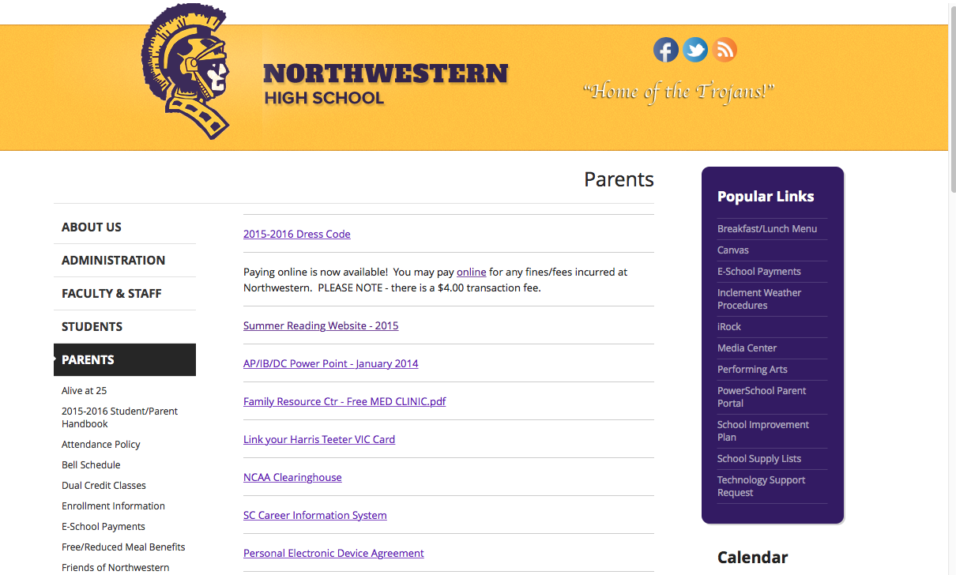

**Click the Canvas link here**

**Step 2**: Click on the gray bar that says “Parent of a Canvas User? Click here for an Account”.

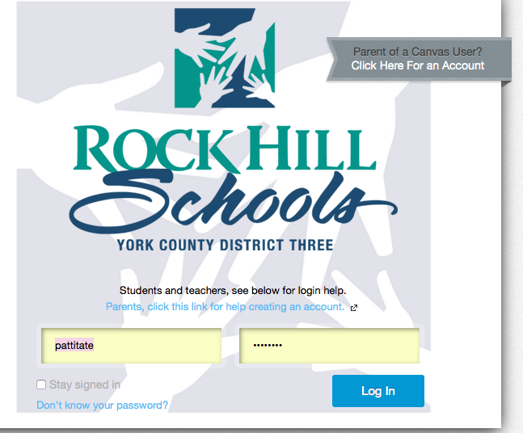

**Parents Click Here**



**Step 3**: After you click the “Parent of A Canvas User” link, you will be directed to the page pictured below. Here you will need the following information: your name, your email address, your child’s user name, and your child’s password. After you enter the information you will receive an email with instructions to complete the process for setting up your parent account on Canvas.

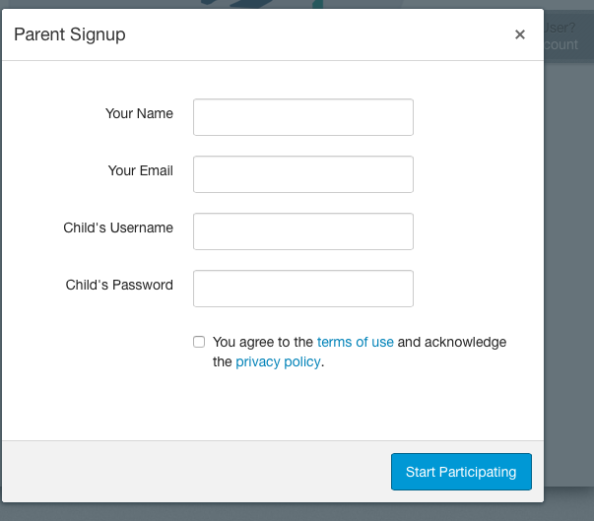

Your child’s **username** is a *number*. The username is the same as the ParentPortal Login username.

The **password** is your child’s birthday:

**MMDDYYYY**